Report on

**COLLEGE WIKIPEDIA**

*Submitted in fulfillment of Infosys Campus Connect project 2015*

**BACHELOR OF ENGINEERING**

*in*

**COMPUTER ENGINEERING**

By

KIRAN IYER-43

PARAS JAIN-46

***UNDER THE GUIDANCE OF***

**Mrs. VANDANA MUNDE**

Assistant Professor

Thakur College of Engineering and Technology

ShyamnarayanMarg, Thakur Village, Kandivali (E), Mumbai-101

Year 2014-2015

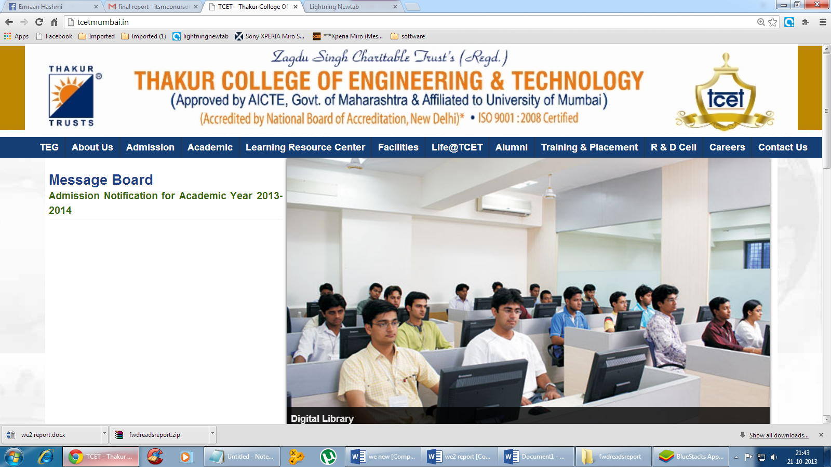

**TABLE OF CONTENTS**

|  |  |  |
| --- | --- | --- |
| SR.NO. | TITLE | PAGE NO |
| 1. | CERTIFICATE | i |
| 2. | ABSTRACT | 1 |
| 3. | PROBLEM DEFINITION | 2 |
| 4. | DESIGN | 3 |
| 5. | CONCLUSION | 14 |
| 6. | REFERENCES | 16 |



**CERTIFICATE**

This is to certify that Kiran Iyer and Paras Jain, of Thakur College of Engineering and Technology, Mumbai have satisfactorily completed the project “**College Wikipedia**” during the **Infosys Campus Connect Pragramme** 2015.

Project Guide

(Mrs. Vandana Munde)